WASHINGTON GREEN BUYING GUIDE
LED Lamps and Retrofit Kits
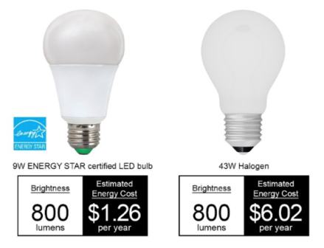
INTRODUCTION/OVERVIEW
Replacing incandescent, fluorescent and high-intensity discharge (HID) light bulbs with LED lamps and retrofit kits is one of the easiest, practical and high-impact sustainability strategies available to public agencies because it protects human health and the environment while saving money. Because LEDs are highly energy efficient, they can significantly lower electricity consumption prevent greenhouse gas emissions. LEDs also reduce lamp replacement and disposal costs because they last a very long time – up to 10 years – and are free of toxic mercury.
This guide is designed to make it easy for State of Washington employees and other contract users to:

- identify high-performance LED lamps and retrofit kits – including products with a third-party certification from the ENERGY STAR Program or DesignLights Consortium – on the State’s Master Contracts; and
- understand how LED lighting equipment will help the State of Washington protect human health and the environment, while saving money.

STATE CONTRACTS OFFERING THESE PRODUCTS
Contract Title and Number: Lamps, Ballasts, Retrofit Kits and Lamp Recycling Containers (03020)
Contract Expiration Date: 01-31-2027

- Vendor: Consolidated Electrical Distributors (CED)
  - EPP-Compliant Brands: Cooper Lighting, Halco, and RAB
  - Contact: Jim O’Rourke, jim.orourke@ced.com, (206) 491-2520
- Vendor: Lekson (Price List)
  - EPP-Compliant Brands: Ark Lighting (LED T8s)
  - Contact: Martin Choi, martin@leksoninc.com, (949) 488-7722
- Vendor: North Coast Electric (Price List)
  - EPP-Compliant Brands: PQL
  - Contact: Ben Weller, ben.weller@northcoast.com, (503) 833-2079
- Vendor: Pacific Lamp and Supply (Price List)
  - EPP Compliant Brands: GE Lighting, Keystone, Philips (Signify), Satco, Sylvania (LEDVANCE)
  - Contact: John Elias, VP, johne@pacificlamp.com, (206) 767-5334

- Vendor: Platt Electric Supply
  - EPP Compliant Brands: Green Creative, Light Efficient Design, Litetronics, and TCP
  - Contact: Jeremy Defoe, Jeremy.dafoe@platt.com, (360) 493-8480
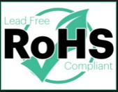
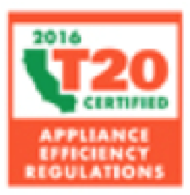
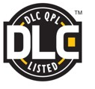
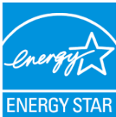
Look for these Eco-Labels!

STATE OF WASHINGTON SUSTAINABILITY SPECIFICATIONS
Minimum Requirements
Environmentally preferred lighting equipment (e.g., lamps, retrofit kits, and luminaires) use LEDs as their lighting source and are either:
    - ENERGY STAR-certified; OR
    - On the DesignLights Consortium (DLC) Qualified Products List (QPL).
Additional Desirable Attributes
Look for LED lamps and retrofit kits that:
- Comply with California’s Title 20 Appliance Efficiency Standards. A list of Title 20-compliant products are listed in the California Energy Commission’s Modernized Appliance Efficiency Database System (MAEDbS).
  - Are labeled “RoHS-Compliant”, which means it complies with the EU’s Restriction of Hazardous Substances (RoHS) Directive and is free of lead solder and several other highly persistent toxic chemicals.
  - Have the longest rated life and warranty.

What do I do with my used lighting equipment?
Mercury-containing fluorescent and high-intensity discharge (HID) lamps as well as incandescent, halogen and LED lamps and PCB-free ballasts can be recycled using Master Contract 00615: Recycling Services: Electronic Equipment and Lights. Total Reclaim offers pre-paid mail-in recycling kits and other recycling services, and provides Contract Users with certificates verifying their lamps and ballasts were responsibly recycled. For more information, contact Pete Keller at pkeller@totalreclaim.com or call (206) 343-1247.
Also, two vendors on Master Contract 03020: Lamps, Ballasts, Retrofit Kits and Lamp Recycling Containers offer lamp recycling containers: CED (via Waste Management) and Pacific Lamp and Supply (via Veolia).
SUSTAINABILITY BENEFITS
Environmental Benefits
Because LEDs are highly energy efficient, they can significantly lower electricity consumption and resulting greenhouse gas emissions and other air pollutants.
Human Health Benefits
Unlike fluorescent and high-intensity discharge (HID) lamps, LEDs do not contain toxic mercury. Purchasing LEDs eliminates exposure to this persistent and bioaccumulative toxic (PBT) chemical during the manufacturing, installation and recycling processes. LEDs that are RoHS-compliant have eliminated or reduced lead, brominated flame retardants and several other PBTs in these products.
Economic/Social Benefits
LED lamps and retrofit kits reduce energy costs over the life of the products and have a relatively short payback period. LEDs also reduce replacement and disposal costs because they last a very long time. LED products on the ENERGY STAR and DLC lists have been evaluated to ensure performance. According to the US Environmental Protection Agency (EPA), “LEDs use up to 90% less energy than incandescent lighting and last 35 to 50 times longer.” Use the ENERGY STAR Light Bulb Savings Calculator to estimate cost savings of using LED lamps, which can be accessed at https://www.energystar.gov/products/lighting_fans/light_bulbs.

APPLICABLE EPP POLICIES
State Laws, Rules, and Enterprise Services Policies
RCW 19.27A: Energy Related Building Standards established the State’s statutory commitment to making its buildings models of energy efficiency.
RCW 70.95M.060: Mercury-free Product Preference directs WA DES to, “…give priority and preference to the purchase of equipment, supplies, and other products that contain no mercury-added compounds or components, unless: (a) There is no economically feasible nonmercury-added alternative that performs a similar function; or (b) the product containing mercury is designed to reduce electricity consumption by at least forty percent and there is no nonmercury or lower mercury alternative available that saves the same or a greater amount of electricity as the exempted product. In circumstances where a nonmercury-added product is not available, preference must be given to the purchase of products that contain the least amount of mercury added to the product necessary for the required performance”.
Executive Orders (EOs)
EO 20-01: State Efficiency and Environmental Performance reinforces the State’s commitment to energy efficiency and reducing greenhouse gas (GHG) emissions: “Improving the energy efficiency of state government operations reduces spending on energy, is a wise use of taxpayers’ dollars, and allows agencies to redirect funds towards citizens’ critical needs…Reducing levels of atmospheric GHGs will support Washington’s fight against climate change, which is already costing Washington businesses and governments—and harming citizens—through more severe wildfires, droughts, heat waves, damaging storms and flooding, as well as degraded water supplies, rising sea levels, increased damage from invasive species, greater stresses on agricultural and forestry crops, damage to salmon fisheries, and harm to shellfish from ocean acidification, among other costly impacts.”

EO 04-01: Persistent Toxic Chemicals directs State agencies “to adopt measures to reduce the use of equipment, supplies, and other products that contain persistent, toxic chemicals” and to “make available for purchase and use by all state agencies equipment, supplies, and other products that do not contain persistent, toxic chemicals unless there is no feasible alternative. In circumstances where a product that does not contain persistent, toxic chemicals is not available, preference shall be given to the purchase of products that contain the least amount of persistent, toxic chemicals.”

RELATED EPP RESOURCES
Surprising Facts
- LED tube lamps typically last 2-3 times longer than the linear fluorescent T8 or T5 lamps they replace.
- LED lamps are about twice as energy efficient as fluorescent lamps and often pay for themselves in a year.
- Plug and play LED lamps can be installed without replacing the luminaire or ballast.
- LEDs can replace nearly every type of general purpose incandescent, halogen, fluorescent and HID lamp.

More Information on this Topic
8 Advantages of LED Lighting (GE Lighting): www.gecurrent.com/ideas/8-advantages-of-led-lighting

EPP Questions? Contact Cheral Manke, DES EPP Coordinator or your Agency’s SEEP or EPP Coordinator.

